SIGNAL PROCESSING

LAB – 4 REPORT

Abhinav Marri

2021112015

**Question 1**

a) Given formula to find the Fourier transform :

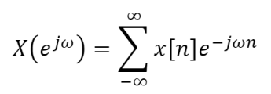

b)

The obtained results are actually in line with the expected analytical solutions .

* For example, the Fourier transform of a delta function will be 1.

The obtained plot :

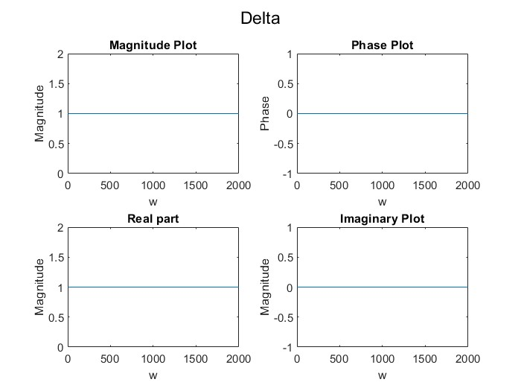

We can see that the DTFT has a constant magnitude of 1 and a phase of 0.

This is observed for the other signals too, that is they are in line with analytical expectations.

c) Below are the obtained Plots for different values of b :

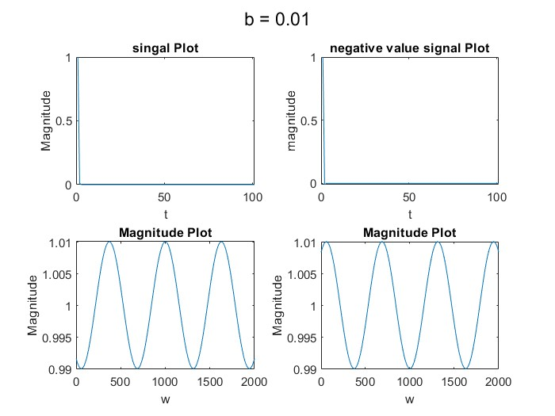 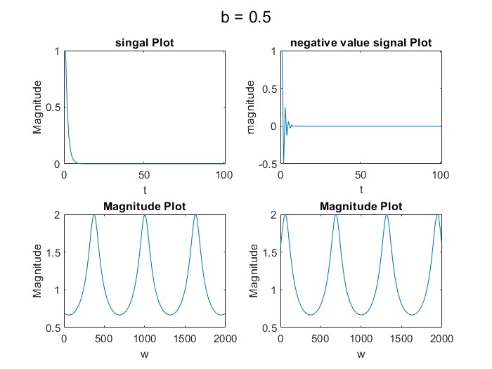

*Figure : plot for b = 0.01 Figure : plot for b = 0.5*

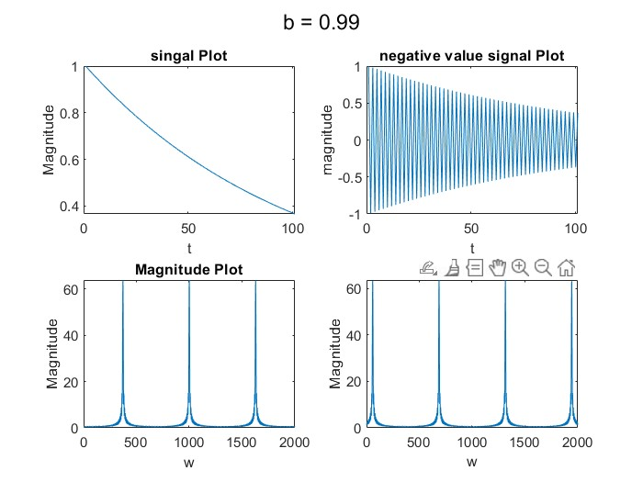

*Figure : plot for b = 0.99*

As we observe, on increasing the value of b the magnitude plots of the DTFTs change. The peaks get sharper. The resultant DTFTs have increased magnitude peaks as the value of b increases. Although the peaks do occur at the same points of w(frequency), this doesn’t change.

**Question 2**

Given Moving Average filter :

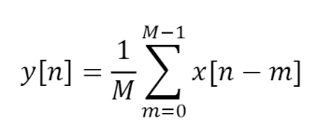

a)

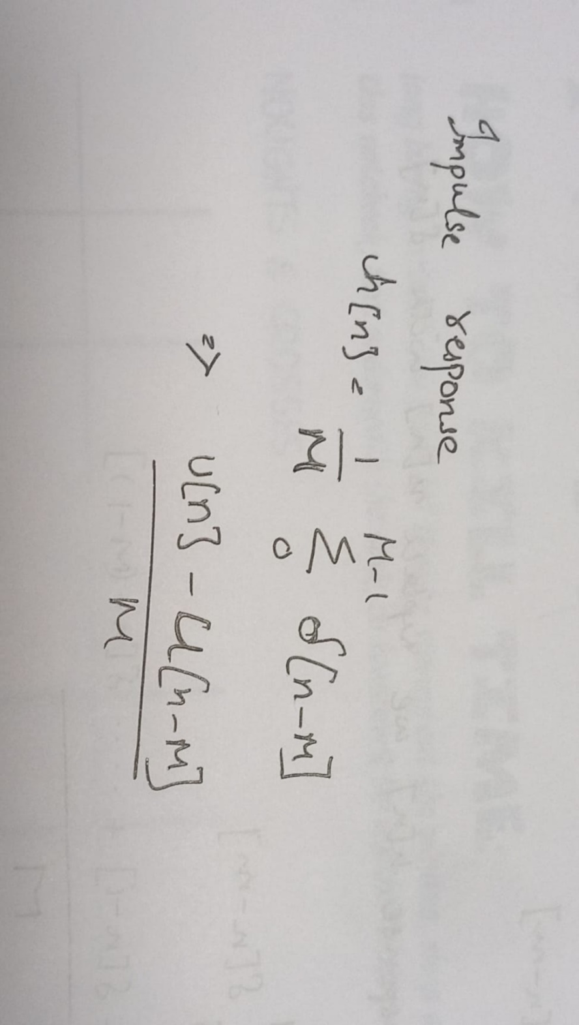

e)

When the value of M is changed :

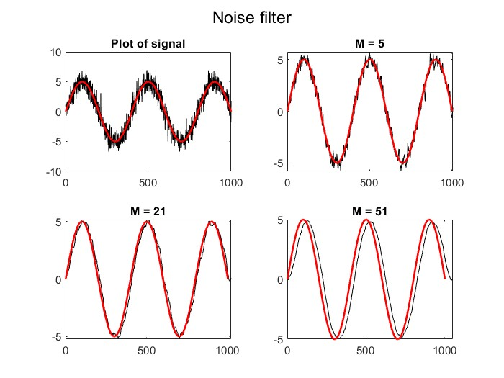

We can observe that as the value of M is increased the filtered signal has lesser and lesser noise, the output becomes more closer to that of the actual wave.

A higher value of M gives us a better result after filtering. As the value of M increases the function considers more samples of the signal to calculate the average, which gives us a more accurate result, eliminating noise.

f) The output for various M :

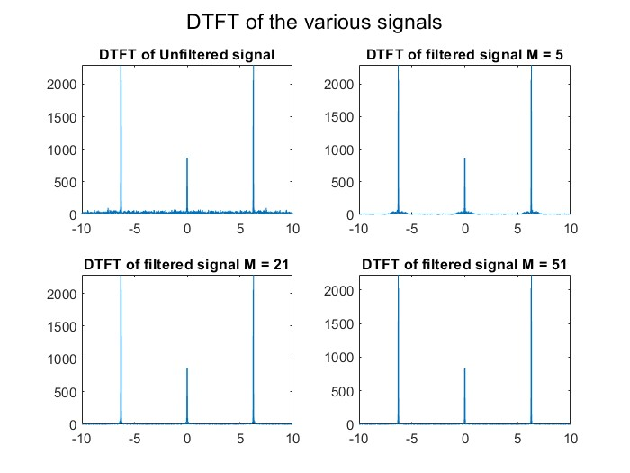

As the value of M increases, we can observe that the amount of noise around the DTFTs of the signals decreases, and the peaks get clearer.

g)

The impulse response of the system will be :

$$h\left[n\right]= ∂\left[n\right]- ∂[n-1]$$

The filtered signal and its DTFT :

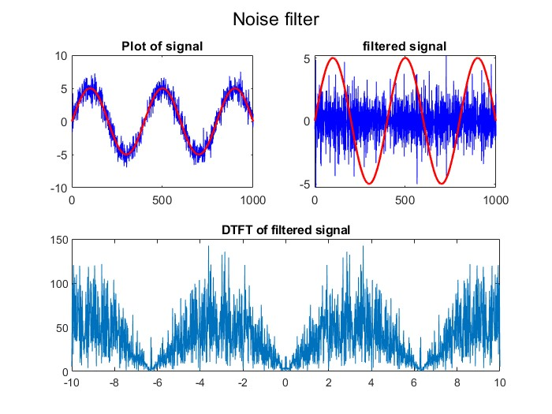

The filtered signal can be observed to still be noisy, ideally this would output a cos wave as our filter is a differentiator and the differential of sin is a cos wave. The filter when implemented in matlab does not give us the ideal output.

h)

Moving Average Filter is a Finite Impulse Response (FIR) Filter smoothing filter used for smoothing the signal from short term overshoots or noisy fluctuations and helps in retaining the true signal representation or retaining sharp step response.

**Question 3**

a) The expected output signal is complex valued.

Output :

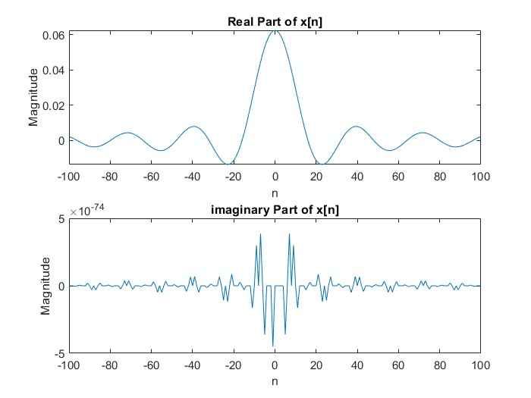

b) When plotting for different values of wc, we obtain :

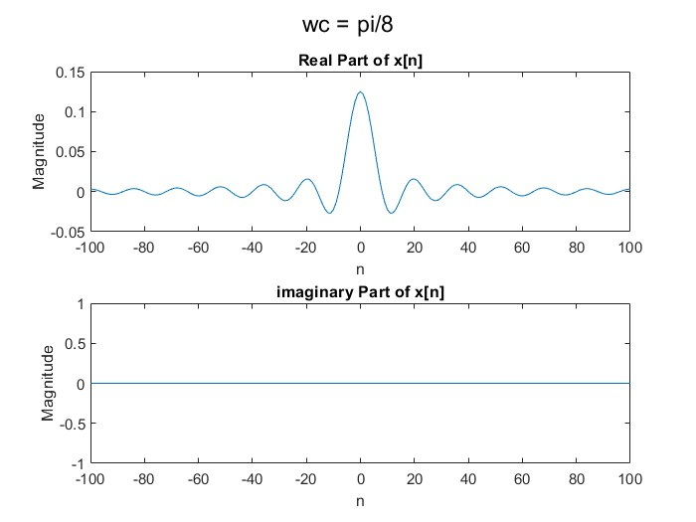 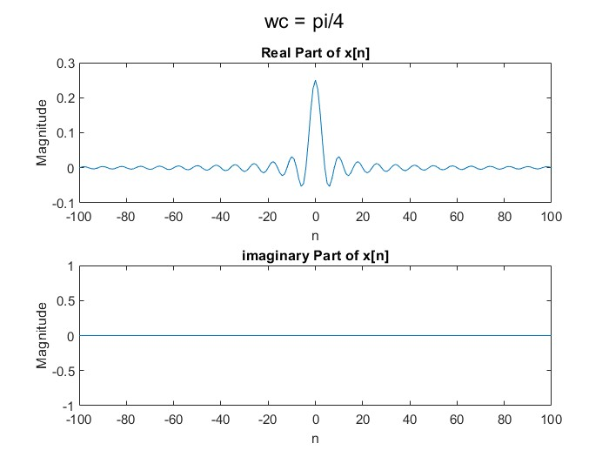

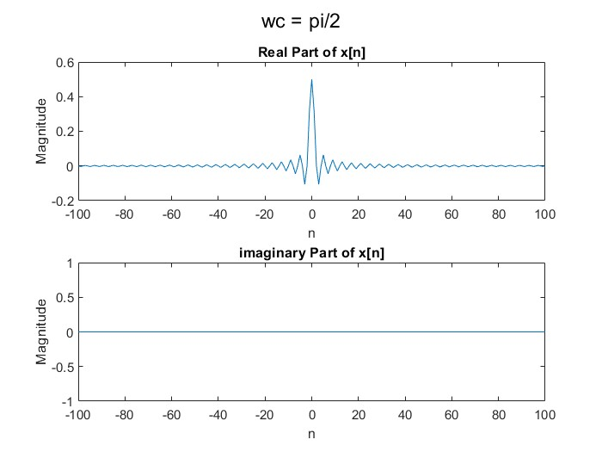

We observe that as the value of pi is increased, the peak of the signal gets clearer and sharper. Also surrounding values are damped to 0. When approaching pi, we get a better peak for every value closer to pi. We see that the signal is approaching a delta function.

The reason for this happening is the increase in the interval of integration that captures more of the signal.

The output for wc = pi.

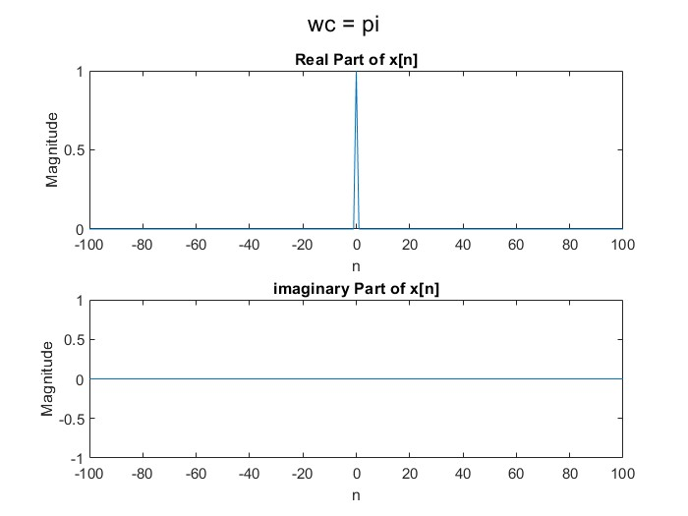

We see that the signal is approaching a delta function.

c) Output for given values of w1 and w2.

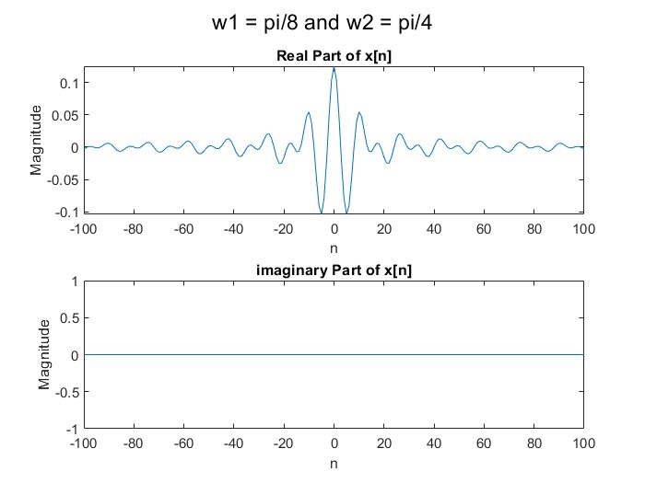

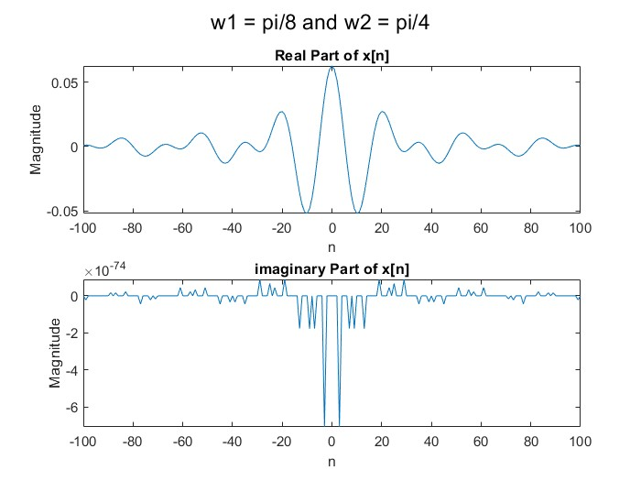

When the values of w1 and w2 are changed to pi/16 and pi/8 respectively, we observe that since we have a smaller interval over which we are integrating the output is less sharp.

Also the inclusion of w = pi/16 introduces imaginary values of x[n] which aren’t present for intervals that are larger. The peak of the plot still stays at n = 0.